Meeting Min  Youth Committee Meeting  May 17, 2022  2:30 PM – 3:30 PM | 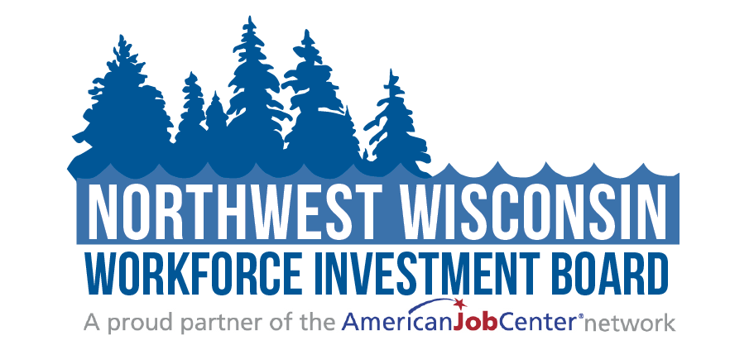
Attendees: | ☐ Mary McPhetridge (Chair)-excused  ☐ LeRoy Forslund- excused  ☒ Melissa Weber  ☐Shannon Stade | ☒Brian Nelson  ☒Patrice Carlson  ☒Mic Isham  ☒ Sheila Young  ☒ Allysa Headley | ☒Jennifer Shearer  ☐Mike BeBeau  ☐Jeff Muse- excused  ☒Amanda Popovich  ☒Jake Wyrzykowski
Guests: | ☒Ryce Davis  ☒Mari Kay-Nabozny | ☐Melissa Rabska  ☐Scott Schultz

Welcome and Opening Meeting Business
  - Call to Order
  - Roll Call
  - Public Meeting Notice
Public Meeting Notice was published to all NWWIB social media avenues, posted on the Website, and sent to the public library systems for posting.
  - Welcome and Introduction of Guests

Previous Meeting Minutes
  - Review and Approve 01.18.22 Meeting Minutes
As presented, Shelia Young made a motion to approve the 1 /18/22 meeting minutes. Patrice Carlson seconded it. Vote taken, carried unanimously.

Current NWWIB Initiatives | Mari Kay-Nabozny
  - WIOA Youth Enrollment and Expenditures | Mari Kay-Nabozny
Mari went over last year's procurement cycle and success stories with the Board.
  - PY 21 Quarter 3 Youth Report | Mari Kay-Nabozny
Mari went over the report numbers with the Board.

Service Strategy Ideas and Outreach for Youth | All

Summer 2022 In-School Youth Plan | Sara White

Forty children are currently enrolled out of forty-three contacted. Rescue Divas is happening with young ladies who are interested in the medical field

Youth Apprenticeship Enrollment Update |Jeff Muse

There are forty currently enrolled, and forty-seven are awarded from the state. CEP is still waiting to hear if they will be awarded for the twenty-three more.

The Board then discussed ideas on how to recruit more Youth.

WIOA 2022 Update | Mari Kay-Nabozny

DWD is putting out a new WIOA in 2022; there will now only be Youth.

PY 22 Youth Contract | Mari Kay-Nabozny

Youth contact will be renewed in June for one more year and then will go out to competitive procurement for 2022. After that, the Board will have to decide if the funds will be for school youth or out-of-school Youth for funds.

Partner Updates on Youth Related Items
  - Comments and Announcements | Committee Members
Mic Isham stated that they would be holding Camp.
There were no other updates.

Adjourn
  - Next Meeting Date: September 20, 2022

Additional Instructions:
Related meeting items are included in the packet for your review before the meeting. Thank you.

