MINUTES  Strategic Directions Committee Meeting  8/16/2022  10:00 AM – 11:45 AM | 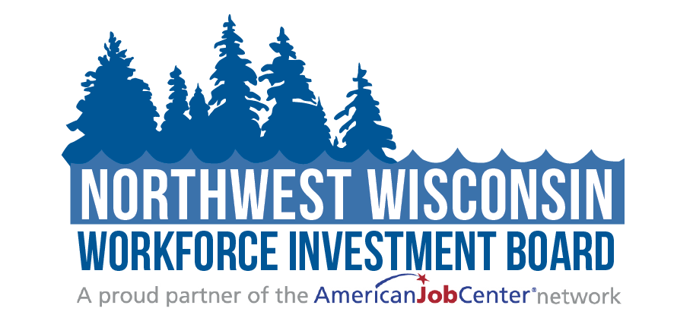
Attendees: | ☒Judy Aspling (Chair)  ☒LeRoy Forslund  ☐Barb Flynn (excused) | ☒Jessica Wagner-Schultz  ☒Kelly Klein  ☒Bambi Pattermann | ☐PC Rassmussen  ☒Thomas Michels  ☐Vacant
Staff: | ☒Mari Kay-Nabozny  ☒Scott Schultz | ☒Melissa Rabska  ☒Kristina Wright | ☐Matthew Filipek  ☐Ryce Davis
10:00 - 10:05 | Welcome and Opening Meeting Business  - Call to Order  - Roll Call  - Public Meeting Notice  - Welcome and Introduction of Guests
10:05 – 10:08 | Previous Meeting Minutes  - Review and Approve 5/17/2022 Meeting Minutes  Motion: Kelly Klein  2nd: Jessica Wagner-Schultz  Motion unanimously approved.
10:08– 10:35 | NWWIB Initiatives & Enrollment Update  Business Services Update | Mari Kay-Nabozny  Mari Kay-Nabozny gave a business services update. An infographic of numbers was included in the packet and presented by staff. Mari spoke of an event on August 25, a webinar on the PERM Program for foreign workers. We have 55 people currently registered for the webinar and 75% of those registered represent small employers. Mari said that it takes about 2 years to get an application approved. Mari said that we will send out our employer services flyer. The State has decided to plan for and host a regional employer round table to try to get to the root of what employers need. Mari said that Scott Schultz is doing most of the outreach.  Scott Schultz spoke about business services. He said that ½ of the services are the incumbent workers program which has 2 participants completed and 3 participants are getting supervisor training. Scott has been working with Northwood Technical and UW superior for possible job fair in October/November.  Pathways Home II Grant | Matthew Filipek  Mari Kay-Nabozny spoke about both Pathways Home and Windows to Work since Matthew Filipek and Ryce Davis are absent.  Pathways  Mari Kay-Nabozny explained how Matthew Filipek goes into County jails to work with those who are about to be released to get them ready to enter the job field. Mari stated that though we would like to be able to work with all the ten counties in our region, there are some challenges to doing that. Matthew had told Mari that he has 38 people enrolled for year 1 of the program with a goal of 200 participants by the end of the grant term. Mari said that it would be nice if we could get into all the jails in our region to serve the upcoming inmates. Sometimes the inmates are transferred, and we have no heads-up when it is happening and a lot of times the inmates don’t even know ahead of time, causing us to lose the participant in the system. Mari commented that since the county jails are technically under the DOC, we could try to get with them to try to get access to the jails that we aren’t currently able to serve.  Support to Communities | Scott Schultz  Scott Schultz said that there are currently 90 participants in Support to Communities with a goal of 130 participants by end of grant. Scott said that Ryce Davis has been working with the student participants to get them enrolled in the grant. Scott commented that we currently do not have any participants in the phlebotomy program.  Windows to Work | Ryce Davis  Windows to Work  Mari Kay-Nabozny said that this program focuses primarily on State facilities. Since we don’t have any state facilities in our area besides the camps, we work with those who have been transferred.
10:35 – 10:40 | Public Relations Report | Melissa Rabska  Melissa Rabska spoke on the Public Relations Report that was included in the packet. She said that it is a little light since it is only covering one month.  Melissa spoke about the podcast and the upcoming fall lineup. There are three episodes that she touched on and they are: 1. An interview with Brian Nelson about apprenticeships, 2. Disability Employment Opportunities, and 3. Labor Market Opportunities.  Mari Kay-Nabozny commented that the CEO’s will be meeting soon and will hopefully approve 2 new Board Members. We are still looking for a third member to fill a vacancy. Mari said that last Thursday we were visited by the DWD Secretary, Deputy Secretary and three other members of DWD. They were able to meet with a some of our participants as well as some of the partners. We introduced them to our childcare cohort, Evergrow workers and they spoke about their worker advancement initiative program participants. Individuals from Northlakes, Bad River Recovery House and a local fire fighter who worked with us were available to speak to DWD while they were here sharing some of their successes. Mari said that DWD have done some social media posts and are working on a press release to highlight some of the programs offered here.
10:50 – 11:05 | PY21 WIOA Contracts and Performance | Melissa Rabska  Melissa Rabska spoke on WIOA Contracts. The graphic was included in the packet and shows the number from the first program contract agreement with CEP. Melissa wanted to show where we are with the contract goals identified in the contract.  Mari Kay-Nabozny described the layout of the graphic, said we started with the contract goal (column 1), re-evaluated with CEP halfway through the year and came up with corrective action adjustment value (column 2), and then the actual numbers of enrollment (column 3).  Melissa Rabska stated that the service participation chart included shows the number of carry over participants and the number of new enrollments needed.  Mari Kay-Nabozny said that these numbers are only for WIOA. The enrollment requirements for WAI are a lot more flexible than those of WIOA. A lot of time we will try to enroll a participant in WAIor other programs along with WIOA to have more funding available, or funding for more support services.  Kelly Klein says that good paying jobs are easy to get right now for those who wants them.  Mari Kay-Nabozny says that not everyone is wanting to go through training to get the better paying job since there are so many good paying ones out there and aren’t pushing the educational training requirement.  Thomas Michels said that if you look at the job openings, the numbers of jobs haven’t dropped much recently.  Mari Kay-Nabozny asked Thomas Michels about the workforce census. Are the number recording remote workers who work for companies in other states as Wisconsin workforce, or do they fall under the census for those states?  Thomas Michels said that the Labor Force Data creates data based on where you live, not where your job is based. QCE data is where the job is located as opposed to LAOS Data that counts if you are working.  Melissa Rabska said that as we worked with the contract, we adjusted the numbers to make them more attainable and we monitor the numbers on a quarterly basis.  Melissa and Mari handed out the DWD report that shows the demographics of the individuals served during PY21. The individuals served aligns well with matrix of race and ethnicity within out 10-county region so we are doing well ensuring equitable service.
11:05 – 11:40 | Strategic Plan Review & Updates for PY23 | Committee Members  Judy Aspling commented that things have changed since the Strategic plan was built.  Mari Kay-Nabozny stated that since the chart was created, we have tripled in size. She believes that all Strategic Plans should be fluid instead of static.  Thomas Michels stated that the 2022 census will be available to use. It is available as or now. The states issue their own estimates. Thomas said that he will be sure to send out an email when the new projections come out.  Link to Governor’s Council on Workforce Investment 2022-2026 Strategic Plan  Mari Kay-Nabozny said that she will go through an overview of the document instead of slide by slide. There are some focus areas that are interesting:  1. Education: Can we offer a co-op for local high schools for childcare training as part of the apprenticeship training.  2. Employers.  3. Workforce.  4. Resource Alignment and organization  Strategic outcomes survey responses  Mari Kay-Nabozny said that we didn’t get a lot of responses from the board members on the survey. The responses that we did get are included in the packet.  *Wondered if we can do more cohorts? Our last cohort had 14 participants enrolled and a wait list of 14 individuals. Youth in the workforce has been going back up. More on the job training was suggested. We would like to do that, but you need the people to do that with.  Mari said that we will review the suggestions and try to see what we can do in the future. There are things that we can’t lead but can support.  Jessica Wagner-Schutz asked if we are doing too much? Should we take a step back and focus more on what we are currently doing and not be so broad?  Mari Kay-Nabozny said that we fill a lot of supportive roles and that being supportive is doable in place of leading the way on various things.  Kelly Klein said that with Broadband, outreach is a supporting role that we can play.  Mari Kay-Nabozny stated that WIOA takes the most of our capacity. Though it only makes up 6% of our budget, it takes about 80% of our time. The question is: How do we get the state to understand that there is more than WIOA? Mari said that they are beginning to ask about some of the other programs we offer and are trying to learn about some of the other ways we can help other than just through WIOA.  Mari Kay-Nabozny said that the current goal for on-the-job training participants for CEP is 25. The used to have 60-80 on-the-job training participants per year.  Mari Kay-Nabozny asked Thomas Michels if we can track the turnover rates regionally? Thomas answered that there is a way to track through the QWI data.  Current Strategic Plan and Map  Mari spoke about the Strategic Plan Map that is included in packet.  Transportation: (Keep, replace, or get rid of?)  Jessica Weber-Schultz says that this is a little too much for the NWWIB staff  Kelly Klein said he never understood why this was included  Judy Aspling said that this is not within our control.  Mari Kay-Nabozny proposed to remove this from the plan, and the committee agreed.  Telecommuting/ Shared workspace:  Jessica Wagner-Schultz has had people reach out to her that have needed Broadband because they live in rural areas that don’t have internet available to them for training or working from home.  Judy Aspling asked how we can learn about the need for this.  Mari Kay-Nabozny agreed with Judy.  Kelly Klein says that it does come up in casual conversations when speaking about working from home. Telecommuting has become a part of our workforce and Kelly doesn’t believe that it is going to go away.  Judy Aspling said that COVID has created this and made employers realize that telecommuting really can work. Just said that she doesn’t know if it should be a focus, but we could look at how do we support it in a broadband vein.  Kelly Klein said that there may be ways to support remote workers, in the shared workspace.  Melissa Rabska said that if people aren’t working in the community, what will keep them from leaving and moving to the area that they have more ties to?  Kelly Klein spoke about how Iron County had held a meet-up for those who worked remotely to get them to connect to others in the community.  Jessica Wagner-Schultz said that social media now takes care of all of that. Events can be organized through social media to get those with similar interests together.  Mari Kay-Nabozny suggested that we take a supportive role in this instead of taking the lead. She asked if we could work on the wording of this and bring it back to the committee later for approval? It was approved.  Judy Aspling stated that though our area may have the people who have the good paying jobs, we may not be the area that has the good paying jobs to attract the people.  Outreach list:  Mari Kay-Nabozny spoke about Kristi Waits. She told how Kristi has an IT background and she has discovered some IT inefficiencies within NWWIB. As such, it has been decided that it is time transition from multiple software programs that we have been paying for, to Microsoft programs that we can utilize for free. We are beginning to make excellent progress on this outcome.  Grant Writer:  Mari Kay-Nabozny said that we want to make sure we are strategic on what we are pursuing. We need to continue to write grants in alignment with our partners. We recently paid for a grant writer’s services but cannot justify going out a seeking the use of a grant writer to share with someone else at this time. Mari suggested removing the part about utilizing a shared grant writer from the strategic plan.  Mari Kay-Nabozny said that if we update our current Strategic plan, we should be able to align with the State’s Strategic plan through 2026.  Judy Aspling said she liked the sound of that since it is not really a good time to try to predict the future.  Mari Kay-Nabozny said that is we were to pull out the stuff that we don’t need right now, and we can then streamline the rest in December since it won’t be ready for the next Board meeting in September.  Bambi Pattermann said that she supports the proposal and said that the changes sound great.
11:40 – 11:45 | Partner Updates on Workforce Related Items  - Comments and Announcements | Committee Members
11:45 | Adjourn  - Next Meeting Date: 10/18/2022

Additional Instructions:
Related meeting items are included in the packet for your review before the meeting. Thank you.

