Meeting Minutes  Strategic Directions Committee Meeting  May 17th, 2022  10:00 AM – 11:45 AM | 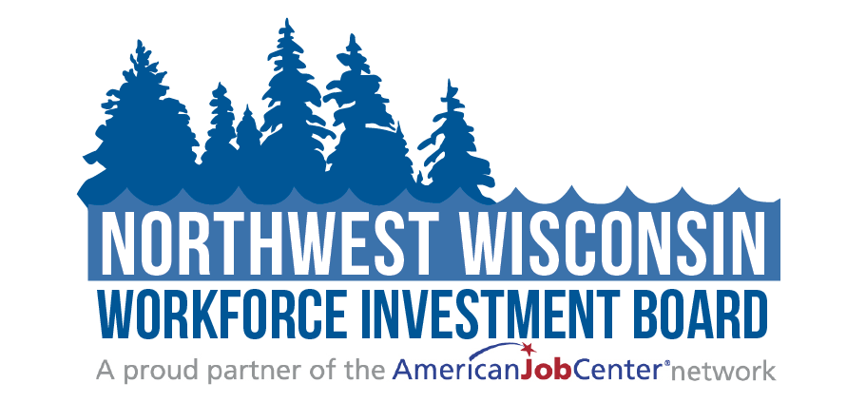
Attendees: | ☒Judy Aspling (Chair)  ☒LeRoy Forslund  ☐Barb Flynn | ☒Jessica Wagner-Schultz  ☒Kelly Klein  ☒Mike BeBeau | ☐PC Rassmussen  ☒Thomas Michels  ☒Bambi Pattermann
Staff: | ☒Mari Kay-Nabozny  ☒Scott Schultz | ☒Melissa Rabska  ☒Ryce Davis | ☒Matthew Filipek  ☐Dawn Knapp  ☒Kristi Waits

Welcome and Opening Meeting Business
  - Call to Order
  - Roll Call
  - Public Meeting Notice
Public Meeting Notice was added to all NWWIB social media avenues, posted on the Website, and sent to the public library systems for posting
  - Welcome and Introduction of Guests

Previous Meeting Minutes
  - Review and Approve 1.18.22 Meeting Minutes
As presented, Kelly Klein made a motion to approve the 1 /18/22 meeting minutes. LeRoy Forslund seconded it. Vote taken, carried unanimously.

NWWIB Initiatives
  - Staffing Update | Mari Kay-Nabozny
    - Re-Entry/ Case Manager
Mari explained the staffing change to the Board. Ryce Davis will be working on W2W and Case management for Support to Communities. Kristi Waits will be doing EO and OSO.
Mari also stated that the plan is to hire an Administrative / Marketing Assistant.
  - Re-entry Work | Matthew Filipek & Ryce Davis
Matthew updated the board on the Pathway home grant he stated that there are currently 18 enrolled in the program.

  - Job Fairs | Scott Schultz
Scott spoke to the Board about the April 19th Job Fair and the tour he took at Delta Diner. There will be another Job Fair on June 28th in Park Falls, WI.
  - Worker Advancement Initiative Update | Kristi Waits
Kristi went over the metrics of the WAI grant.
    - Construction Cohort
Kristi updated the Board on the Construction Cohort and said that is was a success.
    - Early Childhood Cohort
Twelve are enrolled in the Child Care Cohort and the classes are currently taking place.
  - Local Monitoring Progress | Melissa Rabska
Melissa updated the board on the WIOA program monitoring and said that Kristi is working on the EO issues.
Melissa reviewed 20 files and conducted career planner interviews. Findings: inconsistencies with the babel notice, late case note entry, medical and disability issues with a case note within the file. Overall, it was a productive conversation with the career planners and the interviews.

  - PY21 Monitoring Response | Mari Kay-Nabozny
This is the monitoring happening last August. EO has a lot going on because of the change of staff with Kristi taking over. On October 17th they will be doing their next monitoring in person.

Public Relations Report | Melissa Rabska

Melissa went over the Public Relations Reports with the Board.

Revenue Update| Mari Kay-Nabozny

WIG grants update

There are three grants that NWWIB is applying for/ collaborating on. Mari went over each grant with the Board.

WIOA Allocations

Mari discussed the WIOA allocation chart with the Board.

WIOA 2022 Draft Legislation

WIOA 2022 will not label Youth as In-School Youth and Out-Of-School Youth they will be labeled as just Youth.

PY22 WIOA Contracts and Performance | Melissa Rabska

Melissa discussed the contracts for Northwest CEP. These will have to be looked at soon.

Strategic Plan Review & Updates for PY23 | Committee Members

Strategic Dashboard

Mari presented the dashboard, which was updated through March.

Partner Updates on Workforce Related Items
  - Seven Generations Inter-Tribal Leadership Summit | Jessica Wagner-Schultz (https://www.lco.edu/7gensummit)
  - Comments and Announcements | Committee Members
Jessica Wagner-Schultz - Have a site visit for a Master’s in Business Services and Human Science and it will be offered fully credited in the fall.
Bambi Pattermann- Contacted by coordinator looking at offering CDL in the Ashland area in June.

Adjourn
  - Next Meeting Date: August 16, 2022

Additional Instructions:
Related meeting items are included in the packet for your review before the meeting. Thank you.

