Meeting Minutes  One-Stop Operator Committee Meeting  May 17, 2022  1:00 PM– 2:00 PM | 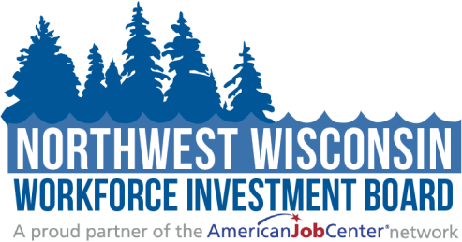

Attendees: | ☒Brad Gast (Chair)  ☒LeRoy Forslund  ☒Bambi Pattermann  ☐Shirley Aviles | ☒Thomas Casey  ☐Jeff Muse  ☒Sue Stevens  ☐Sally Schraders | ☒Thomas Draghi  ☒Kristine Porter  ☒Thomas Kunze
Guests: | ☒Ryce Davis (note taker)  ☒Mari Kay-Nabozny | ☒Melissa Rabska  ☒Kristi Waits

1:00 - 1:05 | - Welcome and Opening Meeting Business  - Call to Order  - Roll Call  - Public Meeting Notice  NWWIB Staff sent the meeting notice to regional Class A newspapers and regional library systems. In addition, the meeting notices were also posted on the Northwest Wisconsin Workforce Investment Board website and all social media outlets.  - Welcome and Introduction of Guests
1:05 – 1:08 | - Previous Meeting Minutes  - Review and Approve Meeting Minutes from 1.18.2022  As presented, Tom Casey made a motion to approve the 1 /18/22 meeting minutes. LeRoy Forslund seconded it. Vote taken; carried unanimously.
1:08– 1:40 | - Regional Operations  - Introduction of new EEO officer and One-Stop Operator Coordinator  Kristi Waits will be the OSO Coordinator and the EO Officer.  - Partners Referrals and Co-enrollments (WAI, STC, COW, and Pathways Home) | Mari Kay-Nabozny  Mari discussed the goals of enrollment numbers and the popularity of Co-Enrollment.  Sue Stevens from CEP also mentioned that all case managers would contact the participants directly.
1:40 – 1:55 | - One-Stop Operator Compliance  - One-Stop Operator Quarterly Report | Kristi Waits  Kristi went over her OSO report with the Board.  - Job Center Visits | Kristi Waits  Kristi updated the Board on her Job Center Visit.  - OSO PY21/22 MOU Update | Mari Kay-Nabozny  There are different signatures needed for the MOU. Mari is hoping that they can extend it to the following year, and then it will just be renewed every year.  - Equal Opportunity Update | Mari Kay-Nabozny  Kristi will be taking over the EO position.  If you have a participant who refuses professional translation, there is a form now available that they must sign.  - DWD Job Center Certification | Mari Kay-Nabozny  Mari spoke of the process that is in the monitoring.  - One-Stop Operator Monitoring and Contract | Kristi Waits  Mari explained the monitoring and contract that she and Kristi would be working on.
- Partner Updates on Workforce Related Items
Comments and Announcements| Committee Members
Kristine Porter told the Board that she had hired someone new.

Tom Casey noted that he is hiring an Office Veteran Specialist and looking for a Supervisor for the Northern Region.

Sue Stevens is looking for a part-time 20-hour-a-week Assistant Career Planner in Spooner.

Brad Gast stated that many High School graduates are confused and have no clue what they want to do after graduation.

2:00 | - Adjourn  - Next Meeting Date: August 16, 2022
Additional Instructions:
Related meeting items are included in the packet for your review before the meeting. Thank you.

