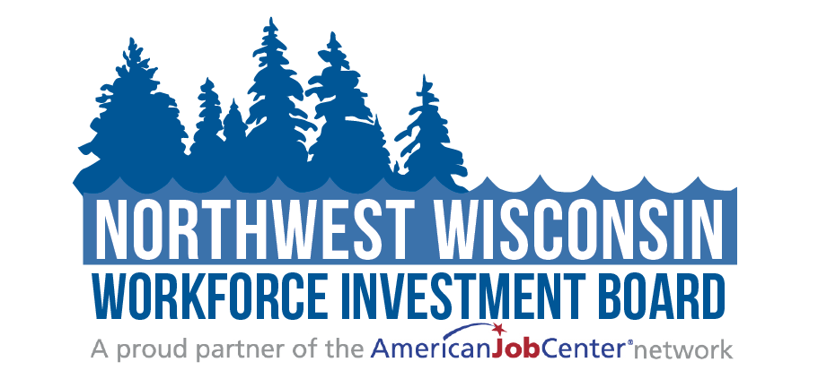
Meeting Minutes
Strategic Directions Committee Meeting
Tuesday, October 18, 2022
10:00am- 11:45am

Attendees: ☒Judy Aspling ☒Kelly Klein ☒Barb Flynn
☐PC Rasmussen ☒Thomas Michels ☒Bambi Pattermann
☒Jessica Wagner-Schultz

Guests: ☒Mari Kay-Nabozny ☒Kristina Wright ☒Melissa Rabska
☒Ryce Davis ☒Scott Schultz
- Welcome and Opening Meeting Business
  - Call to Order
  - Roll Call
  - Public Meeting Notice
NWWIB staff sent the meeting notice to regional Class A newspapers and regional library systems. In addition, the meeting notices were also posted on the Northwest Wisconsin Workforce Investment Board website and all social media outlets.
  - Welcome and Introduction of Guests
- Approval of Minutes
  - Review and Approve September 16, 2022 Meeting Minutes
Motion to approve as presented: Kelly Klein
2nd : Jessica Wagner-Schultz
- DVR Programs & Business Services- Dawn Stocks
Thomas Draghi spoke in place of Dawn Stocks about On the Job (OTJ) training and the services and requirements that the DVR has. Imperative to make sure the job meets the consumer’s goal. Has a youth OJT that pays up to 500 hours and 100% wages for students who are working on the Student OJT. Between 18-21 years old with a disability.
Hard time finding providers (people who provide services to DVR) I.e., NWCEP who help place consumers in employment opportunities to those who are disabled).
Business services that DVR provides- Tom Draghi spoke on some of the business services that DVR supplies. To help business help recruit and retain employees and help them understand disabilities. Can train on working with those with disabilities. All services are at no-cost. To do whatever we can to help businesses grow. (Job Shadows and site visits- School age youth).
- NWWIB Initiatives & Enrollment Update
  - WAI grant | Mari Kay-Nabozny
Mari Kay-Nabozny spoke on the WAI grant which is very flexible with services and training. As of September, there were 189 people enrolled and now 200+ are enrolled in the program. This grant ends in September 2023 and it allows individuals to co-enroll with other programs for more assistance possibilities. WAI created the Move to Manufacturing program which proposed to serve 200 people, but it hasn’t proven to be of interest for job seekers. We are trying to re-work the funds in another direction. Talking about creating a position that would be located at the Tech college but would work for the workforce board to help direct the students to the various programs that will help them. We don’t want to completely do away with the Move to Manufacturing idea but would like to work on other things right now instead of having the money just sit there not helping anyone. Bambi Pattermann commented that they are still trying to promote the Move to Manufacturing Training program. Judy asked if the proposal Mari spoke about would work and Bambi said that she would be supportive of it to use the money in a helpful way. The companies are taking people off the street and training them themselves instead of choosing credentialed training. People can get a job without having to have educational training. Is there a way that we can help expand the class size? There is a student: instructor ratio. Please know if you are working in different areas who are needing employment, we have a lot of subsidized and OJT funds available.
  - Pathways Home II Grant | Matthew Filipek
Matthew Filipek spoke about the Pathways Home II Grant. As of 10/17- we have 55 participants. The goal is to reach 200 participants. Matthew is currently trying to shift some of the workload so he has more time in the hands-on part of the job and less time on the paperwork portion. We are currently working with 7 counties and are trying to get involved with Rusk county. There is a corrective action plan by SWWDB since we are under enrollments and expenditure goals. It has been proposed that we serve fewer individuals and give back some money to be disbursed to other boards. All boards had a 200 participants goal, but we have a smaller population. It is believed that there is a work capacity to bring on part-time staff to help Matthew with the administrative portion of the job.
  - Support to Communities | Scott Schultz
Scott Schultz spoke about the Support to Communities Grant. He mentioned that we currently support 108 participants which make us #1 In the state for providers. Our goal is to serve 130 participants and we are on our way.
  - Windows to Work | Ryce Davis
Ryce Davis spoke on the Windows to Work program. Ryce stated that there are currently 13 participants enrolled in this program. Ten of those participants are currently employed and the 3 remaining participants are actively looking for employment. We only work with transfers since our area doesn’t have any State Correctional Facilities.
- Public Relations Report | Melissa Rabska
Melissa Rabska spoke about the Public Relations Report. Since the board recently met and was able to review the report in its entirety, Melisa gave a brief overview. She mentioned that there is a media release supporting the Pathways Home II Program to employers and the community to try to get more of a presence. She mentioned that Support to Communities has a Job Fair scheduled. Melissa mentioned that Momentum West had issued an eblast on workforce challenges that had a positive response. It hit two different audiences with the same language. Melissa also commented that our last podcast will be released later this week. The topic of that podcast will be Disability Employment Awareness.

- Strategic Plan Review & Updates for PY23 | Committee Members
  - Review changes from August
Mari Kay-Nabozny spoke about any changes that were made since the last meeting. Mari said that we worked on the Strategic Plan Map and executed the changes that were talked about. The work chart was updated adding new job titles and synopsis of the positions. It also addresses life after the split from NWCEP. We replaced old charts with the new, updated versions, updated the census information that was provided to NWWIB by Thomas Michels, and we tweaked the Strategic Issues that were covered at the previous meeting. Mari commented that she wants this to be a living document that will change when needed and not a static file. The current version will be good for 2023-2026.
  - Finalize for full NWWIB review in December
Mari Kay-Nabozny commented that the Strategic plan will be completed and finalized for Full Board Review at the December Board meeting.

Motion to advance the Strategic Plan to the Board for approval: Kelly Klein
2nd: Thomas Michels

- Partner Updates on Workforce Related Items
  - Comments and Announcements | Committee Members
Bambi Pattermann spoke about enrollments for the fall semester. She mentioned that the Millwright and Plastic Injection programs were approved for certified pre-apprenticeship programs.
Thomas Michels spoke about the population in our areas. The under-18 population has decreased by 1.7% since 2020.
Jessica Wagner-Schultz commented that Lac Courte Oreilles Ojibwe University has celebrated its 40-year anniversary and had a lot of social media questions about the loud noises coming from campus. Jessica commented that their celebration featured fireworks.

- Adjourn
  - Next scheduled meeting date: January 17^{th,} 2023 at 10:00am or at the call of the Chair

Related meeting items are included in the packet for your review before the meeting. Thank you.

