Meeting Minutes  Strategic Directions Committee Meeting  January 18, 2022  10:00 AM – 11:30 AM | 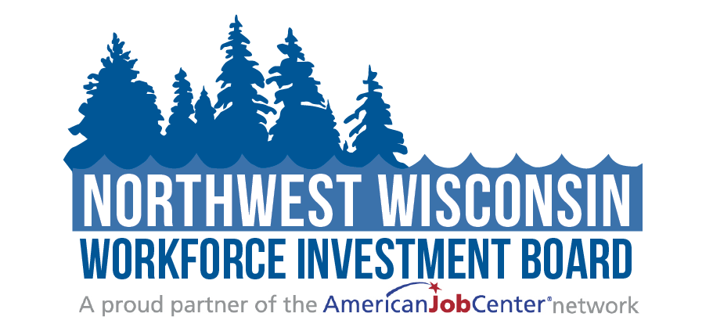
Attendees: | ☒Judy Aspling (Chair)  ☒LeRoy Forslund  ☒Barb Flynn | ☒Jessica Wagner-Schultz  ☒Kelly Klein  ☒Mike BeBeau | ☒PC Rassmussen  ☐Thomas Michels  ☒Bambi Pattermann
Guests: | ☒Mari Kay-Nabozny  ☒Scott Schultz | ☐Melissa Rabska  ☒Ryce Davis | ☒Matthew Filipek  ☐Dawn Knapp  ☐Kristi Waits
10:00 - 10:05 | Welcome and Opening Meeting Business  - Call to Order  - Roll Call  - Public Meeting Notice  Public Meeting Notice was published to all NWWIB social media avenues, posted on the website, and sent to the public library systems for posting  - Welcome and Introduction of Guests
10:05 – 10:08 | Previous Meeting Minutes  - Review and Approve 10.18.21 Meeting Minutes  Kelly Klein made a motion to approve the 10/18/2021 meeting minutes as presented. Bambi Pattermann seconded. Vote taken, carried unanimously.
10:08– 10:35 | NWWIB Initiatives  - Business Services Update | Mari Kay-Nabozny  Mari went through the employer services summary, calculated through the end of December. Mari stated a job fair was held in Medford, and it was agreed that Virtual Job fairs were not favored. However, the drive-through Job fair had better numbers. Scott plans to hold a drive-through Job Fair in spring located in Superior and Ashland.  TDConn22 will be held on April 7th-8th in Wisconsin Dells; all Board members can sign up.  Mike BeBeau also stated that Hayward FBLA would be taking place on February 16^{th;} it is $30.  - Additional staff consideration  Mari spoke to the Board about possibly hiring a part-time employee or contracting with an organization to help Scott out with his program.  The Board felt that the funding should be looked at, and then the options will be discussed at the Executive Committee Meeting.  - Pathways Home 2 Grant | Matthew Filipek  There are currently eight participants that are enrolled. Three of those participants have been released, and two are already employed.  Matthew stated that he has plans to meet with two more potential participants next week.  The goal is to have 200 enrolled.  - Support to Communities Grant | Scott Schultz  There are 28 enrolled in Support to Communities. Items for their upcoming Spring Semester have already been purchased.  Scott is also working with Dan Miller to have a CNC and Machine Tool class in May.  - Windows to Work | Mari Kay-Nabozny  Mari spoke of Nathanial from CEP Windows to Work giving notice. Matthew will be helping in the future and will know more in May.
10:35 – 10:40 | Public Relations report | Melissa Rabska  PodCast with Road Trip Nation will be released soon.  Melissa has been facilitating the Regional Career Pathway session. 40 employers have attended.
10:40- 10:50 | Grants update| Mari Kay-Nabozny  WIG grant update  WIG grant will be doing a round two with ARPA funds with approximately 40 million available. NWWIB plans to reapply for their $1.2 million grant idea as well as Road Trip Nation
10:50 – 11:10 | Strategic Plan Dashboard Review | Committee Members  This has not changed since the December Board meeting; the data has only been calculated until the end of November. Mari noted that she feels the team is doing well. It will be updated through the end of March as well  The next time it will be updated through the end of December.
11:10 – 11:30 | Partner Updates on Workforce Related Items  - Comments and Announcements | Committee Members  Jessica Wagner-Schultz stated that there is a B.S. Teacher Education class starting in LCO.  Barb Flynn discussed the open positions in Bayfield County and how they are struggling to fill them.  Bambi Pattermann said classes started yesterday, and their FTW numbers were down, but the headcount was up. Also, working with NCT to move to the manufacturing program, a meeting is coming up on the 26th of January to share more about the program.
11:30 | Adjourn  - Next Meeting Date: May 17, 2022

Additional Instructions:
Related meeting items are included in the packet for your review before the meeting. Thank you.

